Broadly Reconfigurable and Expandable Automation Device (BREAD) – Slice Datasheet: Audio Analysis / Fourier Transform Slice
By: Nicholas Whisman (ngwhisma@mtu.edu) – Revision 0, on 17. May 2021

Short Device Description
This device takes in an audio signal from either an Aux cable or a quarter inch cable, and shifts, amplifies, and breaks down the signal into constituent frequency ranges. These ranges, or the full signal, can then be analyzed via fast Fourier transform.

Quick Information
Device at a Glance
Short title | Audio Analysis / Fourier Transform Slice
Part # | SLC-AAFT
Repository Link | Link to OSF or other repository
Academic Paper DOI | DOI link to published paper
Device Cost | Monetary cost of the device
Assembly Difficulty | Medium. Millable.
Application Area | Controls + Robotics (Vibrational/Tonal Sensing + Correction), Limited Frequency Range Audio

Device Connections
J2- Aux
Pin # | Description | Rating
1 | A standard aux cord used for personal electronic devices. | Standard aux cord protocol is to set maximum possible voltage at ~ 0.477 V. Plan accordingly with amplifier configuration to not exceed 5V total.

J3- Quarter Inch
Pin # | Description | Rating
1 | Quarter Inch jack used in professional audio settings. | Quarter Inch jacks typically output 1.736 V at a maximum. Plan amplifier tweaks accordingly.

Commands
Set Up (no significant returns)
Byte: Address | Bit: 1 | Float: Target Temp | Float: Ramp Rate (d/m)
Read (Returns Magnitudes of Specified Bins)
Byte: Address | Bit: 0 | Float: 0 | Float: 0
Stat Read (Returns Requested Statistic)
Byte: Address | Bit: 0 | Float: 0 | Float: 0

Schematic

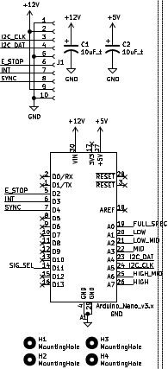Figure 1: Standard Core Slice Components

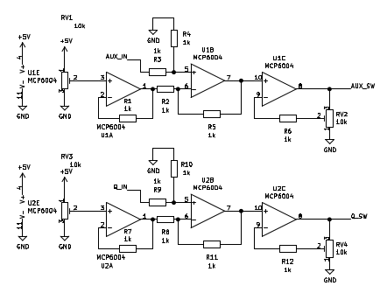Figure 2: Aux + Quarter Inch Channel Amps

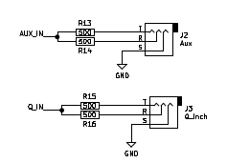Figure 3: Aux and Quarter Inch Inputs

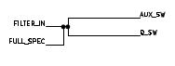Figure 4: Signal Transfer Bridge

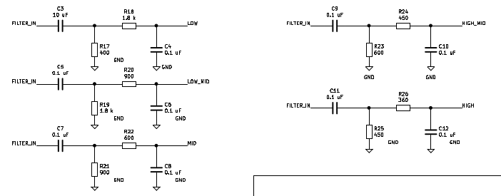Figure 5: Range Filters

Bill of Materials
Designator | Description | Quantity | Cost / part | URL
U1-2 | 4 Stage Amplifier Chip | 2 | 0.44 | https://www.digikey.com/en/products/detail/microchip-technology/MCP6004T-I-ST/523078
J2 | Aux Cord Jack | 1 | 1.18 | https://www.digikey.com/en/products/detail/cui-devices/SJ1-3533NG/738701
RV1-4 | 10k 12 Turn Trim Pot | 4 | 4.16 | https://www.digikey.com/en/products/detail/bourns-inc/3266W-1-103LF/1087907
R26 | 1206 Packaging 360Ω Resistor | 1 | 0.10 | https://www.digikey.com/en/products/detail/yageo/AC1206FR-07360RL/5897483
R24-25 | 1206 Packaging 450Ω Resistor | 2 | 0.10 | https://www.digikey.com/en/products/detail/yageo/RC1206FR-07453RL/728924
R22-23 | 1206 Packaging 600Ω Resistor | 2 | 0.10 | https://www.digikey.com/en/products/detail/yageo/RC1206FR-07604RL/729038
R20-21 | 1206 Packaging 900Ω Resistor | 2 | 0.10 | https://www.digikey.com/en/products/detail/yageo/RC1206FR-07909RL/729166
R18-19 | 1206 Packaging 1.8 kΩ Resistor | 2 | 0.10 | https://www.digikey.com/en/products/detail/yageo/RC1206JR-071K8L/729204
R17 | 1206 Packaging 400Ω Resistor | 1 | 0.10 | https://www.digikey.com/en/products/detail/yageo/RT1206BRD07400RL/5936956
R13-16 | 1206 Packaging 500Ω Resistor | 4 | 0.10 | https://www.digikey.com/en/products/detail/yageo/RC1206FR-07499RL/728944
R1-12 | 1206 Packaging 1 kΩ Resistor | 12 | 0.10 | https://www.digikey.com/en/products/detail/yageo/RC1206FR-071KL/728387
J3 | Quarter Inch Jack | 1 | 1.58 | https://www.mouser.com/ProductDetail/Neutrik/NMJ6HCD2?qs=ZNZTMDotSRlKYl2qFVJbQA%3D%3D
C4-12 | 1206 Packaging 0.1 µF Capacitor | 9 | 0.16 | https://www.digikey.com/en/products/detail/yageo/CC1206KRX7R8BB104/5884627
C3 | 1206 Packaging 10 µF Capacitor | 1 | 0.66 | https://www.digikey.com/en/products/detail/yageo/CC1206KKX5R6BB106/5195344
C1-2 | 1206 Packaging 10 µF Capacitor | 2 | 0.64 | https://www.digikey.com/short/qfrbqfhd
A1 | Arduino Nano | 1 | 22.00 | https://www.digikey.com/en/products/detail/arduino/A000005/2638989
J1 | 01x10 Female Header Pins | 1 | 0.79 | https://www.digikey.com/short/23bfwwjh

Construction & Fabrication
List any tools that are required and short guide on the order which parts should be soldered / assembled. Be sure to note any specialized methods and point out components that may easily be soldered in the incorrect orientation. Additionally include at least one picture of the assembled board (include both sides if there are components on both sides).
[Image of the assembled Circuit Board]
Fig #. Subtitle should go here.

Configuration & Calibration
Include a list of default jumper and potentiometer positions:
Hardware Positions
- Turn P1 to be roughly 50%
- Turn P2 to be completely closed (turn clockwise until potentiometer clicks)
- Place a jumper to short out J3. Etc…
Detail any key parameters the end-user may want to adjust in the firmware, and if there are any special instructions before programming the Slice.
Tools Required For Calibration
- An oscilloscope with at least 15Mhz sampling
- A multimeter. Etc…
List all of the tools / instruments required for calibration. Provide a detailed & step by step guide on how to calibrate (or validate) each unique type of channel on the card. Include what variables in the firmware may need to be adjusted (and when). Attach a wiring diagram for each relevant calibration circuit.
[Image of the calibration circuit]
Fig #. Subtitle should go here.

Usage & Constraints
List the relevant constraints for each type of channel on the card. These parameters may be quantities like max current, max voltage, frequency, sampling frequency, etc.
List an example wiring diagram of the slice in use, as well as some suggested applications
[Image of the example usage wiring diagram]
Fig #. Subtitle should go here.

General Comments on Slice
This section is intended as a catch-all for any topics that are relevant to the Slice that don’t fit in any other category.

Revision Notes
- Rev 0 – Initial document release (DATE HERE)

